Paper 4:
Severity Calculation Results
Table 1: Training Results
Table X: Performance Evaluation of the Proposed U-Net with EfficientNet B0 Model
Class Name | Dataset Split | Dice Score | IoU | Accuracy | Precision | Recall | HD95 (pixels)
Corrugation of Rails | Training | 0.8592 | 0.7546 | 0.9770 | 0.8792 | 0.8449 | 56.34
Corrugation of Rails | Validation | 0.7508 | 0.6081 | 0.9643 | 0.6777 | 0.8539 | 71.86
Corrugation of Rails | Test | 0.7923 | 0.6611 | 0.9643 | 0.7959 | 0.7960 | 53.11
Hogging of Rails | Training | 0.8249 | 0.7036 | 0.9817 | 0.8418 | 0.8173 | 65.55
Hogging of Rails | Validation | 0.7747 | 0.6356 | 0.9766 | 0.8671 | 0.7042 | 68.90
Hogging of Rails | Test | 0.8054 | 0.6748 | 0.9803 | 0.7971 | 0.8282 | 63.90
Rail End Batter | Training | 0.8567 | 0.7524 | 0.9909 | 0.8910 | 0.8310 | 88.51
Rail End Batter | Validation | 0.7005 | 0.5556 | 0.9843 | 0.7455 | 0.6963 | 52.36
Rail End Batter | Test | 0.7401 | 0.6091 | 0.9900 | 0.7586 | 0.7315 | 37.37
Rail Wear | Training | 0.7843 | 0.6544 | 0.9675 | 0.8196 | 0.7681 | 103.51
Rail Wear | Validation | 0.7446 | 0.6298 | 0.9414 | 0.6854 | 0.8352 | 66.74
Rail Wear | Test | 0.8179 | 0.7069 | 0.9784 | 0.8641 | 0.7975 | 37.94
Scabbing of Rails | Training | 0.7456 | 0.6050 | 0.9607 | 0.7755 | 0.7398 | 111.52
Scabbing of Rails | Validation | 0.6986 | 0.5473 | 0.9401 | 0.7358 | 0.6808 | 98.68
Scabbing of Rails | Test | 0.7707 | 0.6408 | 0.9669 | 0.7982 | 0.7665 | 72.90
Shelling and Black Spots | Training | 0.9285 | 0.8683 | 0.9681 | 0.9282 | 0.9301 | 66.14
Shelling and Black Spots | Validation | 0.8642 | 0.7706 | 0.9437 | 0.9024 | 0.8363 | 54.76
Shelling and Black Spots | Test | 0.8734 | 0.7779 | 0.7779 | 0.9063 | 0.8497 | 0.8497
Wheel Burns | Training | 0.8228 | 0.7022 | 0.9771 | 0.8673 | 7951 | 57.67
Wheel Burns | Validation | 0.7630 | 0.6255 | 9709 | 0.8084 | 0.7404 | 54.18
Wheel Burns | Test | 0.7843 | 0.6501 | 0.9764 | 0.8813 | 0.7147 | 52.56

Table 2: Run Time Analysis : UNet with Efficient B0 Model

Class Name | Total training time | Avg epoch time
Corrugation of Rails | 648.7608280181885 | 32.437679302692416
Hogging of Rails | 641.5772881507874 | 32.07859612703324
Rail End Batter | 576.3827295303345 | 28.81885929107666
Rail Wear | 1689.1185228824615 | 84.45562257766724
Scabbing of Rails | 968.5693674087524 | 48.42815896272659
Shelling and Black Spots | 1889.065639257431 | 94.45297468900681
Wheel Burns | 903.5448400974274 | 45.17695897817612

Comparative Visualisations of different Defect Types
Defect Type | Real Image | Ground Truth Image | UNet++ (EfficientNet B0) Predicted Image  Severity Value  Action Recommended | UNet Predicted Image  Severity Value  Action Recommended
Rail Wear | 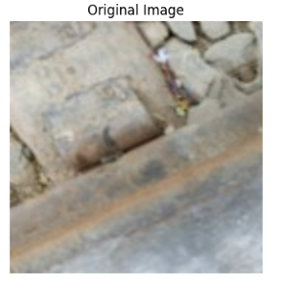 | 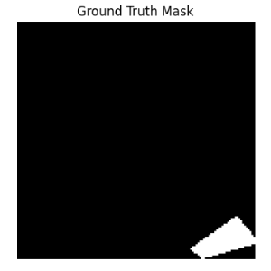 | 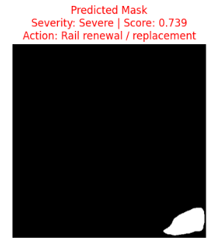 | 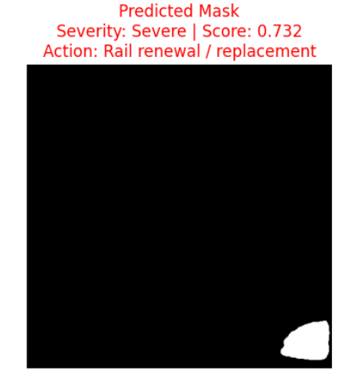
Rail Wear | 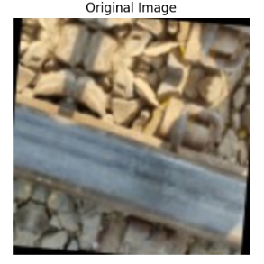 | 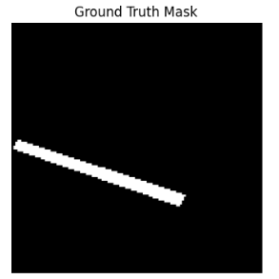 | 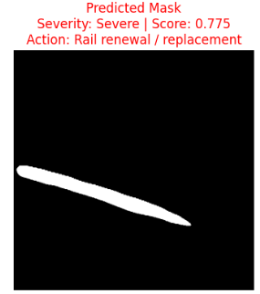 | 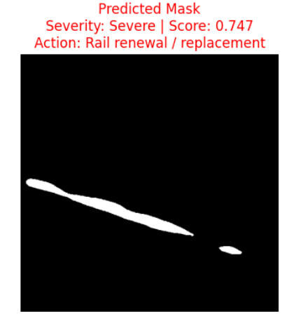
Rail Wear | 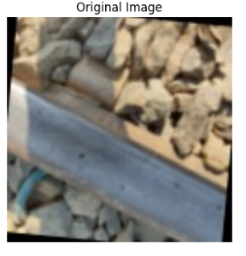 | 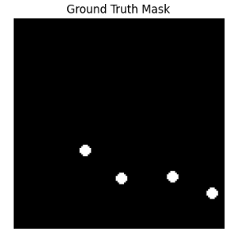 | 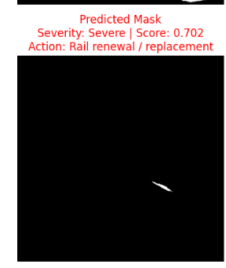 | 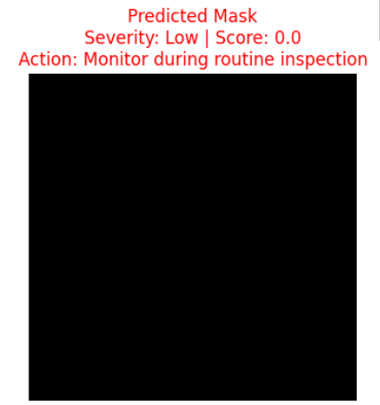
Rail End Batter | 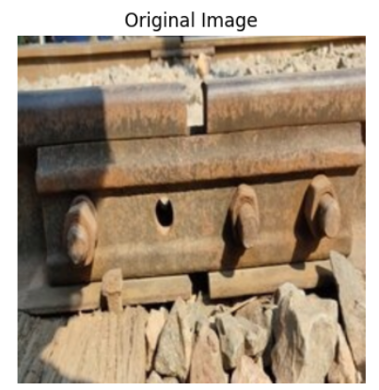 | 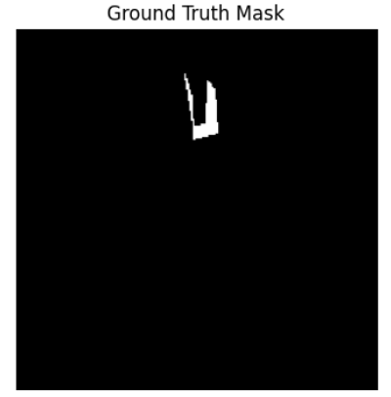 | 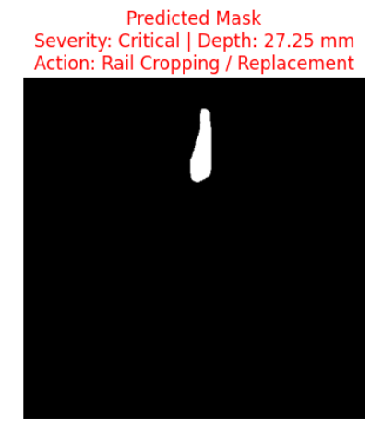 | 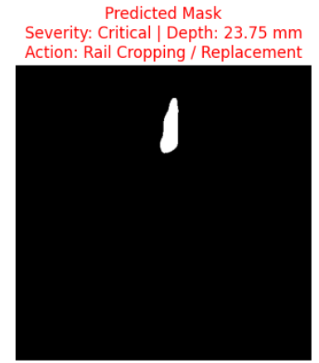
Rail End Batter | 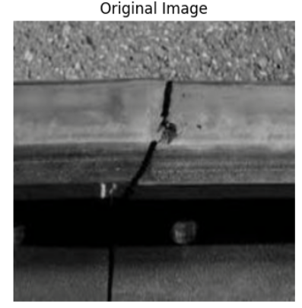 | 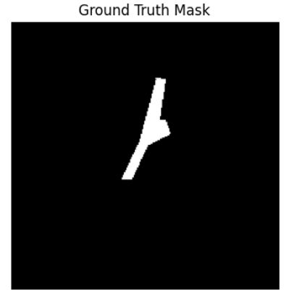 | 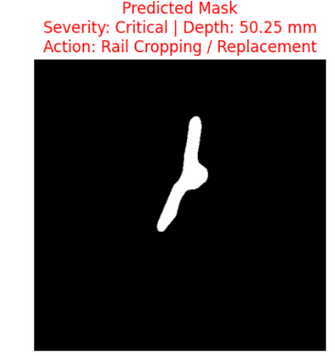 | 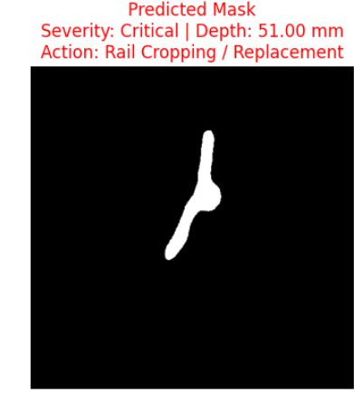
Rail End Batter | 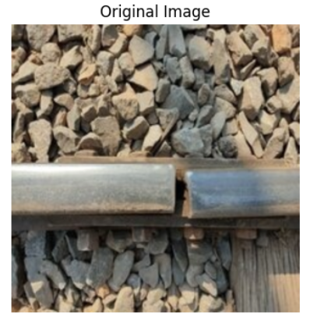 | 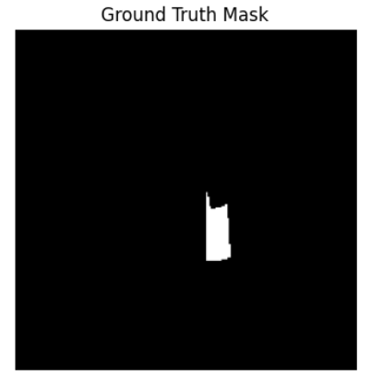 | 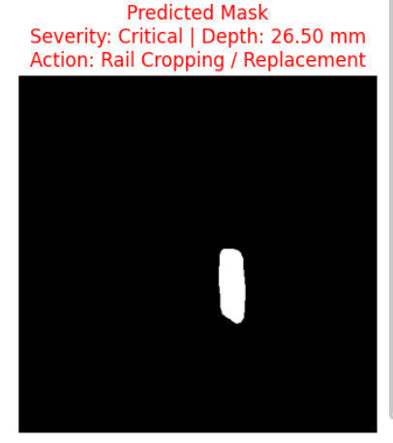 | 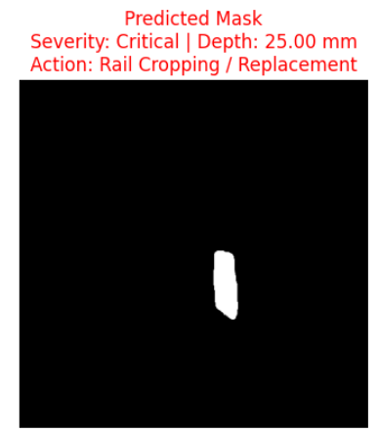

Defect Type | Real Image | Ground Truth Image | UNet++ (EfficientNet B0) Predicted Image  Severity Value  Action Recommended | UNet  Predicted Image  Severity Value  Action Recommended
Hogging of Rails  214  215  217 | 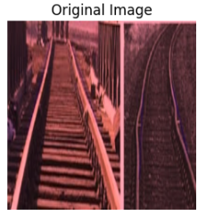 | 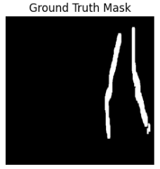 | 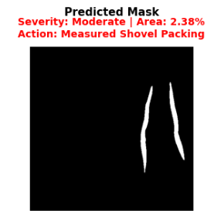 | 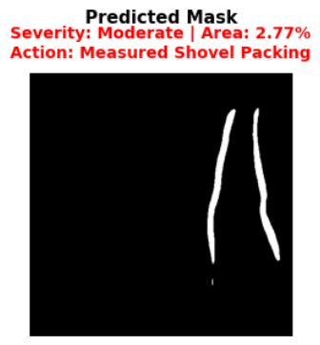
Hogging of Rails  214  215  217 | 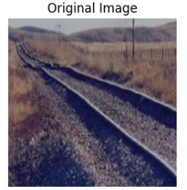 | 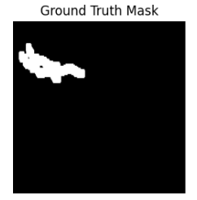 | 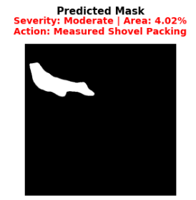 | 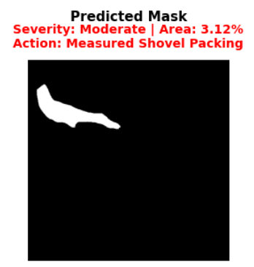
Hogging of Rails  214  215  217 | 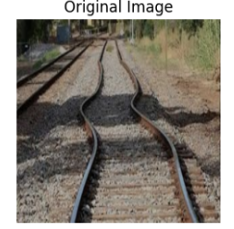 | 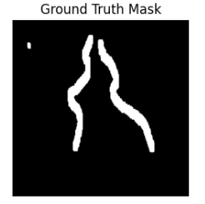 | 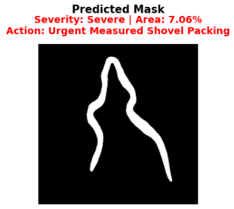 | 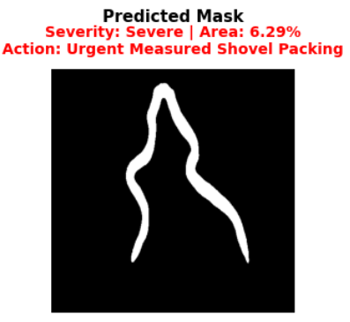
Scabbing of Rails | 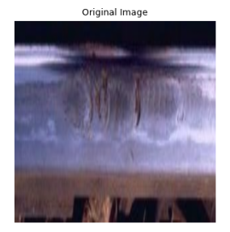 | 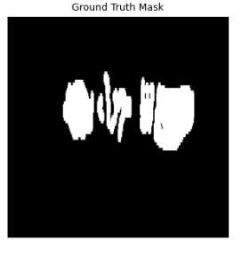 | 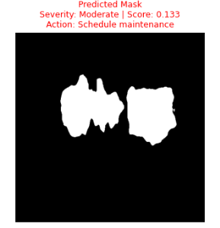 | 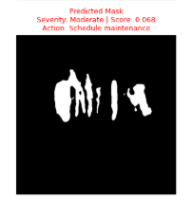
Scabbing of Rails | 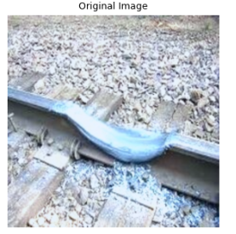 | 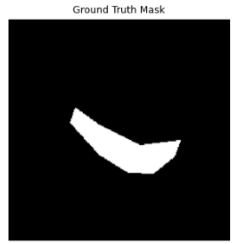 | 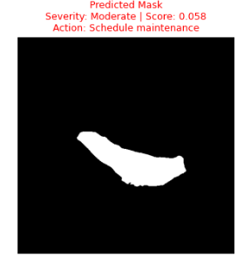 | 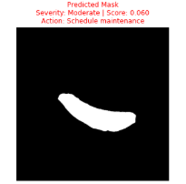
Scabbing of Rails | 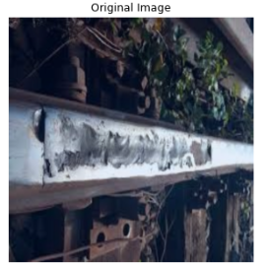 | 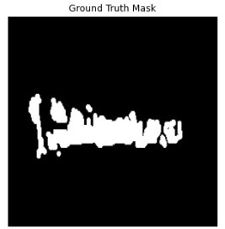 | 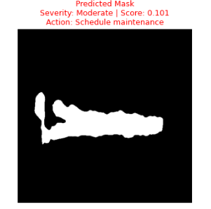 | 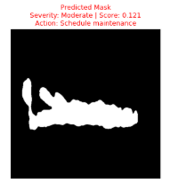

Defect Type | Real Image | Ground Truth Image | UNet++ Predicted Image  Severity Value  Action Recommended | UNet  Predicted Image  Severity Value  Action Recommended
Wheel Burns | 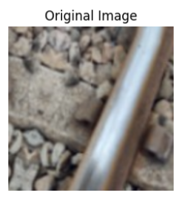 | 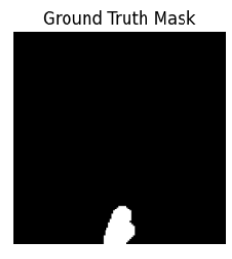 | 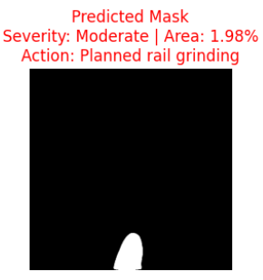 | 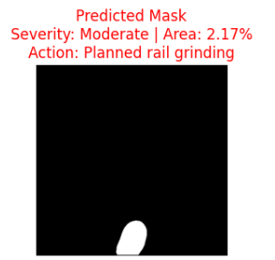
Wheel Burns | 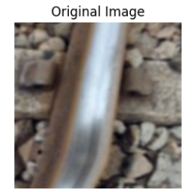 | 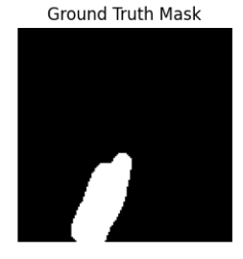 | 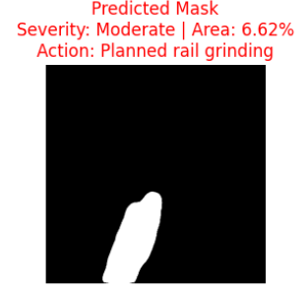 | 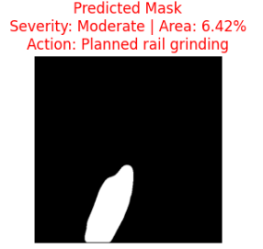
Wheel Burns | 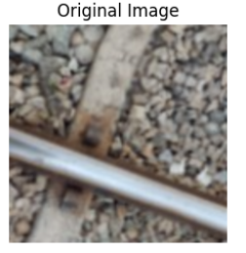 | 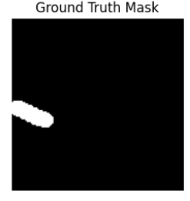 | 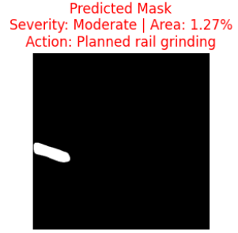 | 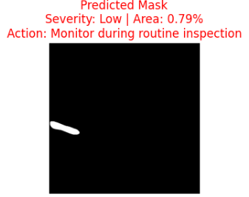
Shelling and Black Spots | 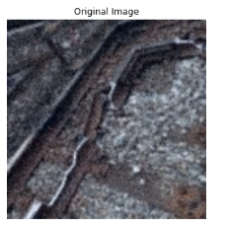 | 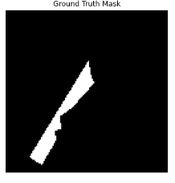 | 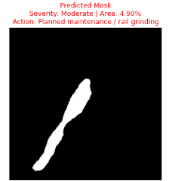 | 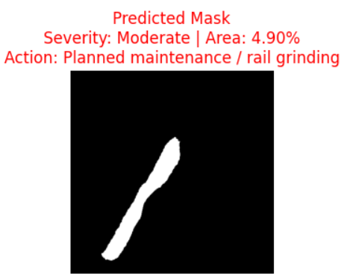
Shelling and Black Spots | 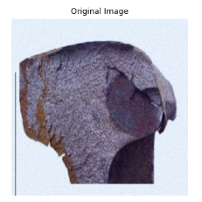 | 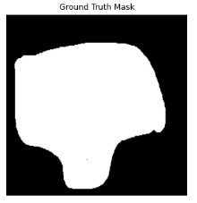 | 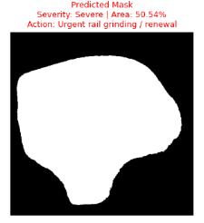 | 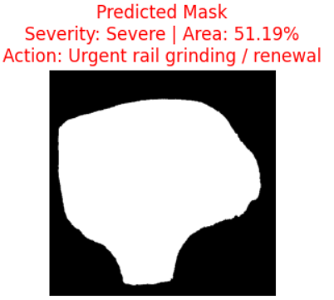
Shelling and Black Spots | 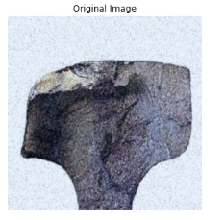 | 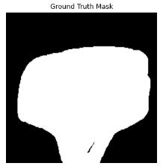 | 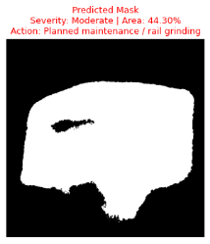 | 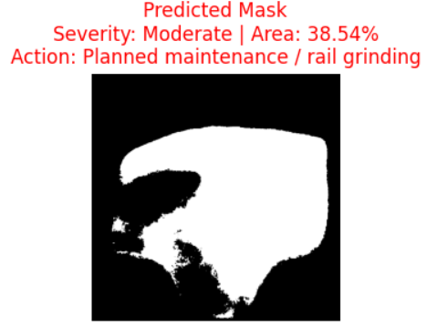

Defect Type | Real Image | Ground Truth Image | UNet++ EficientNet B0 Predicted Image  Severity Score  Action Recommended | UNet Predicted Image  Severity Value  Action Recommended
Corrugation of Rails | 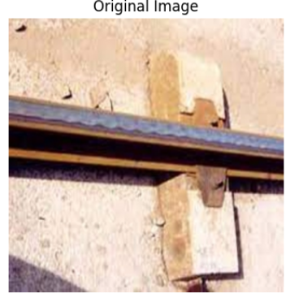 | 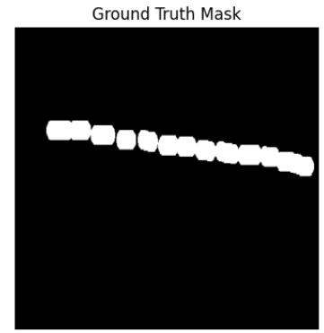 | 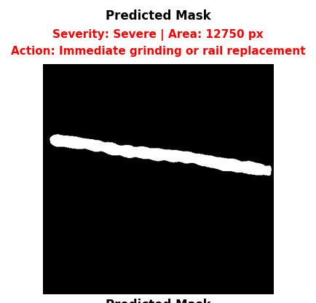 | 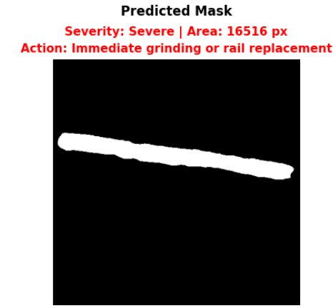
Corrugation of Rails | 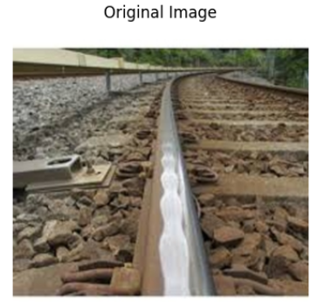 | 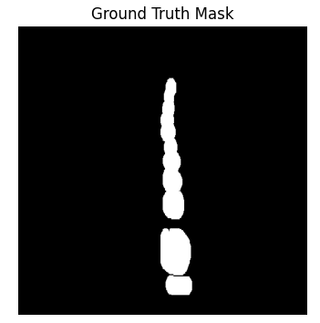 | 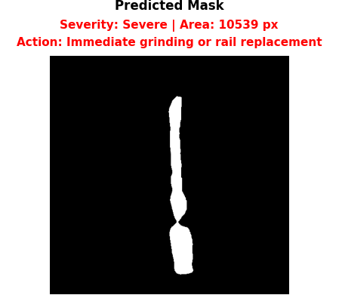 | 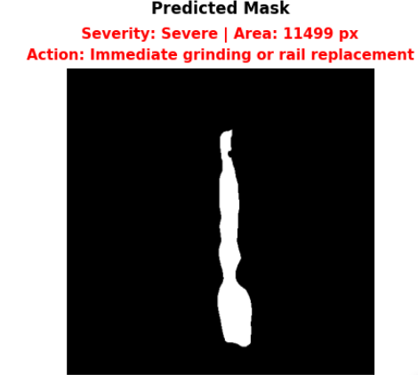
Corrugation of Rails | 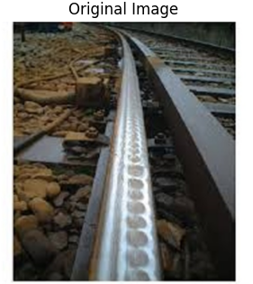 | 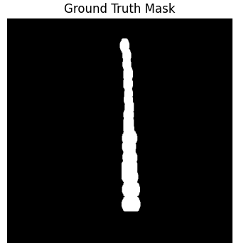 | 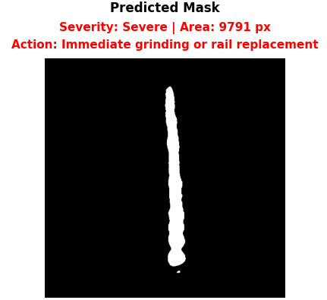 | 

